**COMES AS YOU ARE…**

But I’m on prescriptions. Stay on them.

Come as you are.

I have diet limitations.

Food Freedom Method – Eat what you want.

Come as you are.

I need a kosher diet.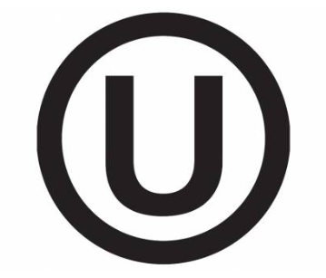

It is Kosher.

Come as you are.

I am pregnant.

No worries, it 100% natural.

The ONLY thing holding you back, is YOU!

Give yourself the gift of life: **RENEW You!**